Department of Computer Science & Engineering

G. Narayanamma Institute of Technology & Science

(for women)

Shaikpet, Hyderabad - 500 104.

Smart bridge LOGO

Accredited by NACC, Approved by AICTE & Affiliated to JNTU-H

An ISO 9001:2008 Certified

Batch of 2017-2018

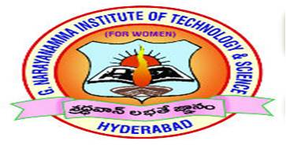

**SMART AGRICULTURE SYSTEM WITH IOT**

**BY**

**B.MEGHANA (14251A0570)**

**B.KAVYA (14251A0571)**

**G.SUSHRUTHA (14251A0575)**

**P.SANJITHA REDDY (14251A0598)**

**Internal Guide Head of the Department Dr. K. Venugopal Rao Dr. M. Seetha**

**Professor Professor & HOD**

**ABSTRACT**

###### Agriculture plays vital role in the development of agricultural country. In India about 70% of population depends upon farming and one third of the nation’s capital comes from farming. Issues concerning agriculture have been always hindering the development of the country. The only solution to this problem is smart agriculture by modernizing the current traditional methods of agriculture.

This project aims at making agriculture smart using automation and IOT technologies. It includes various features like smart GPRS based remote controlled monitoring which senses temperature, humidity, moisture and detects the water level.

It makes use of wireless sensor networks for noting the soil properties and environmental factors continuously. Various sensor nodes are deployed at different locations in the farm, all the sensors are interfaced with Arduino. By analyzing the real time data read through sensors appropriate operations are taken through the server.

**SYSTEM REQUIREMENTS:**

**Software Requirements:**

Platform - Windows

Development Tool - Arduino

**Hardware Requirements:**

Name of the Processor - i5 processor

Hard Disk Capacity - 1 Tera Byte

RAM Capacity - 8GB

Hardware Parts - GPS modem, LM35 temperature sensor, Humidity sensor, Soil moisture sensor, LCD display, Arduino board